Monica Cimino holds Maryland State Certification to teach both Biology and ESOL and has been employed as a high school teacher for Montgomery County Public Schools since 1996. She was a registered dietitian for twenty years and taught nutrition and biology at Montgomery College. | 
Yu-Ying Huang is an ESOL teacher at Wootton High School in Montgomery County Public Schools, and is currently pursuing National Board Certification. Ms. Huang teaches ESOL Modern World History, ESOL levels 1, 3 and 4. | 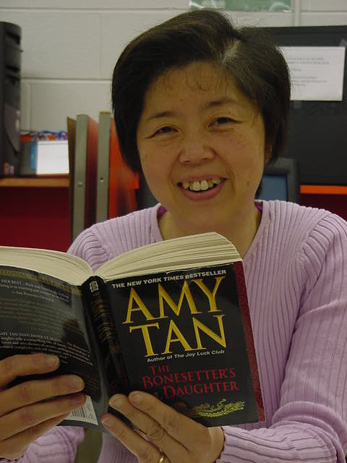
Diana Schroeder is an ESOL Transition Specialist at Albert Einstein High School in Montgomery County Public Schools. She has taught ESOL for 20 years at the middle and high school levels. She has also taught METS and Math to ESOL students and has previously been an ESOL Resource Teacher. | 