Feedback from Participants

Plus | Delta
- Specific strategies were presented  - Small group allowed more interaction  - The information we got was very helpful.  - I got to ask the questions that I wanted to ask.  - Put in shoes of ESOL student’s agony and ecstasy.  - Time to ask questions  - Information also written so you can take it to remember  - Business-like  - Wealth of information  - Organization  - Free discussion  - Interaction with Bill, Afie, Yu-Ying was great  - Explanation of programs was helpful  - Video really put us in ESOL student’s place!  - I’m motivated to do some new things  - Very practical  - Good coverage of instructional delivery as well as teachers – parent – student interaction | - Needed more time  - Maybe a chance to talk about individual students, but maybe this isn’t the appropriate forum for that.  - Difficult to fit as much as we want to know in the time allotted.  - Concrete examples of strategies can be improved  - Refreshments next time! ☺

Next Steps
- Work with English for strategies for recently exited students
- Could you do a presentation for the math department on ways to break down the material or strategies for success?
- Would like to sit in an ESOL class.
- Meet with each department to answer questions.
- This was helpful but sufficient for me. I always have Bill or Yu-Ying to consult with for ESOL students, but perhaps more for ELL learners – and those we may not know about.

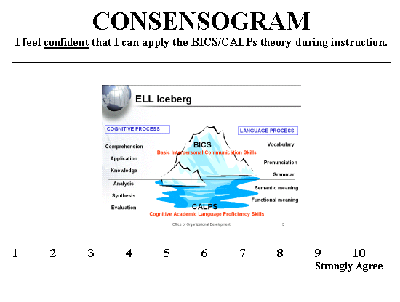

Green = Before presentation Red = After presentation

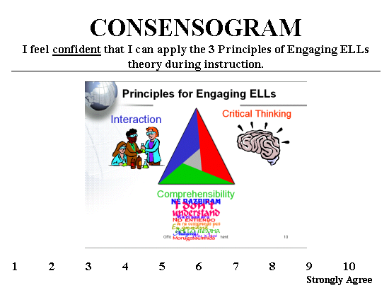

Green = Before presentation Red = After presentation

